1. Open Control panel and select Network and Sharing center.
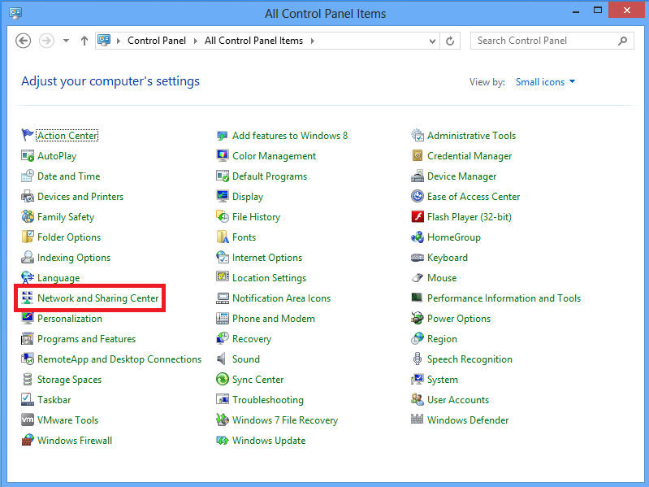

2. Choose Set up a new connection or network option.
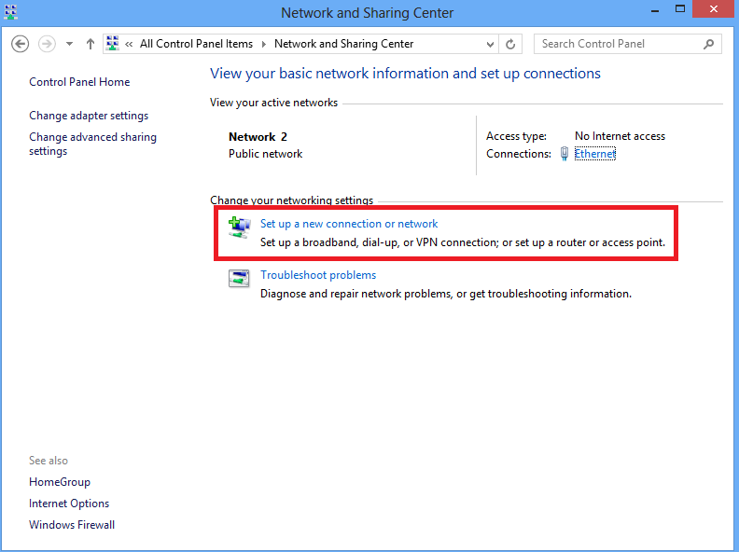

3. Choose Connect to a workplace option and click Next.
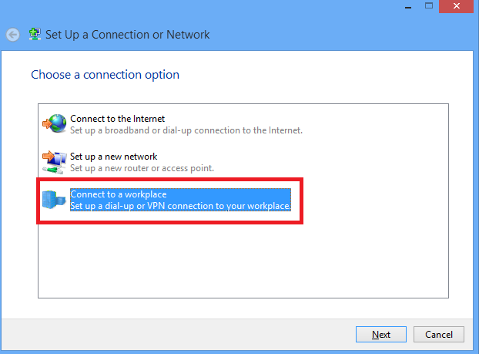

4.Click Use my Internet connection (VPN) option.
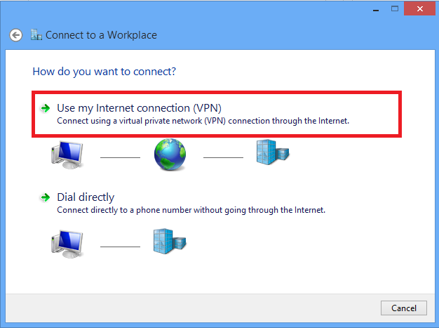

5. Enter IP address of ASA's WAN interface 82.xx.xx.xx and click Create.
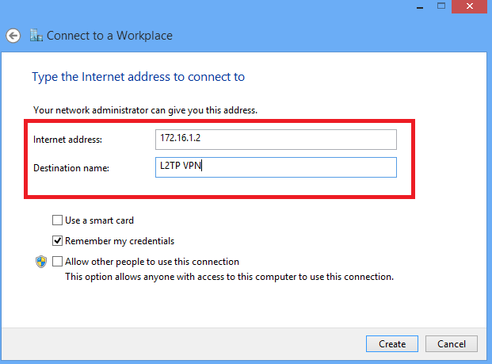

6. On Network and Sharing Center, choose Change adapter settings option on the left pane of the window.
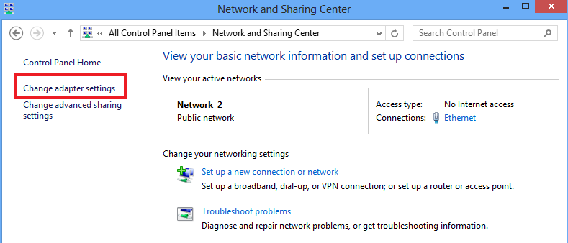
7. Right click the recently created adapterfor L2TP VPN and choose Properties.
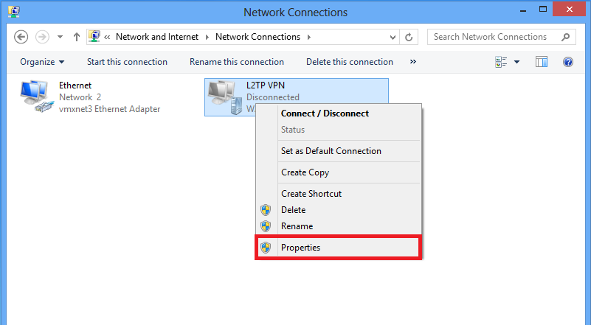
8. Navigate to Security tab, choose the Type of VPN as Layer 2 Tunneling Protocol with IPsec (L2TP/IPsec) and then click on Advanced settings.
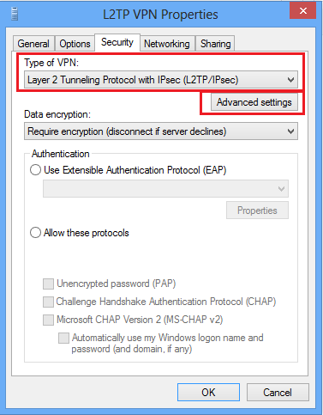
9. Enter the preshared key: dalloyau-vpn and click OK.
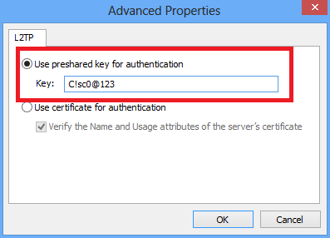
10. Choose the authentication method as Allow these protocols and ensure that only "Microsoft CHAP Version 2 (MS-CHAP v2) checkbox is checked and click OK.
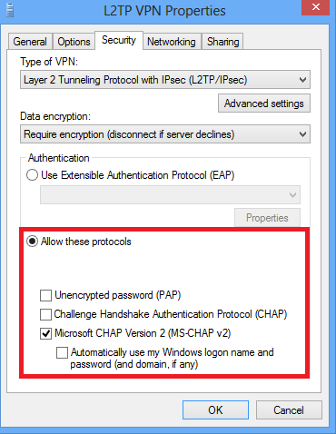

11. Under network connections, right click on L2TP VPN adapter and choose Connect/Disconnect.
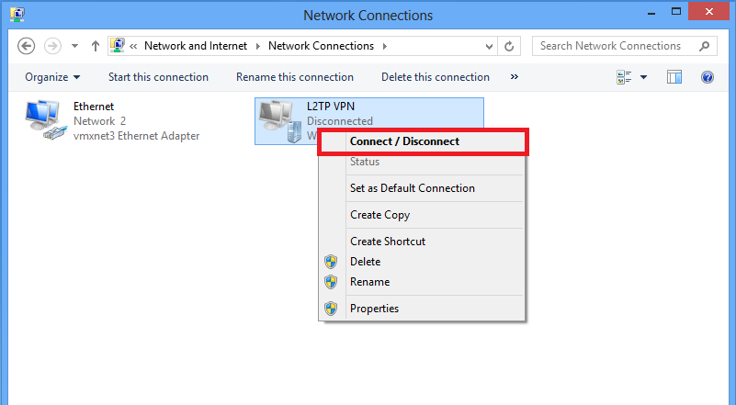
12. Networks icon will pop up and click Connect on L2TP VPN connection.
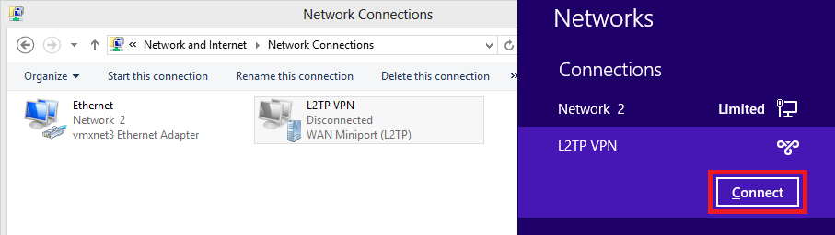

13. Enter the user credentials and click OK.
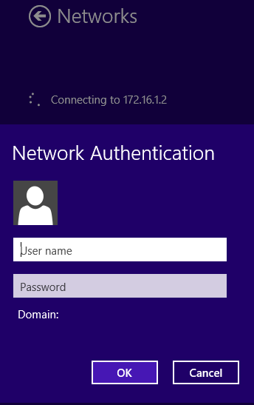
If the required parameters are matched on both the ends, L2TP/IPsec connection will be established.
